Messages – SPA Application – JS Apps Exam
You are assigned to implement a Messaging Web front-end application (SPA) using HTML5, JavaScript, AJAX, REST and JSON with cloud-based backend (Kinvey). The app keeps users and messages. Users can register, login, view their received messages and sent messages, delete message (from their sent archive), send a message and logout.
Using libraries like jQuery and React is allowed but is not obligatory.

Create a Kinvey REST Service to Hold Users and Messages
Register at Kinvey.com and create an application to keep your data in the cloud.
In the Users collection, import the provided JSON file with sample users to get started with template data. In the Kinvey Console, select Users from the navigation of the left, click Settings in the upper right then scroll down to the Import section:
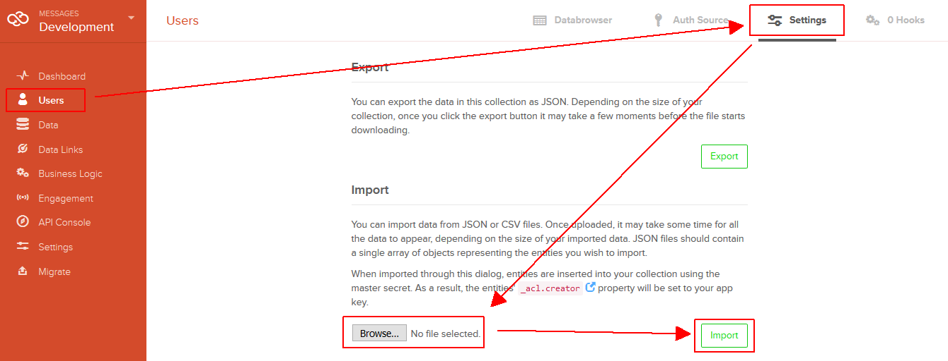
Create a collection messages(sender_username, sender_name, recipient_username, text) to hold the messages. All the fields will hold text values. The “_kmd.lmt” field is automatically created by Kinvey and will hold a date and time in the traditional for JavaScript dates ISO8601 format returned by Date.toJSON().
Create a new collection and import the provided JSON file with sample messages like shown below:
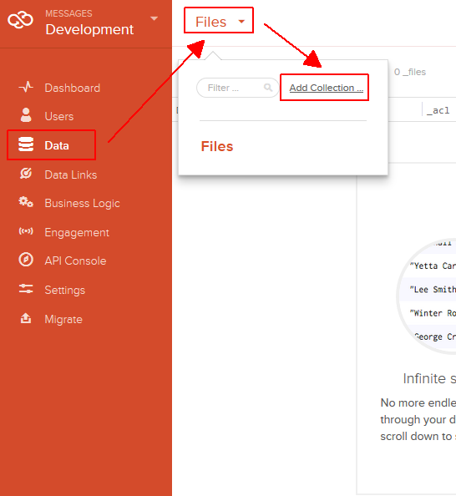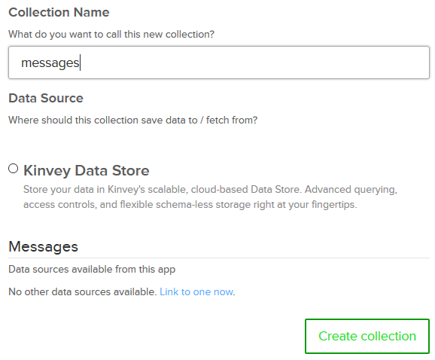
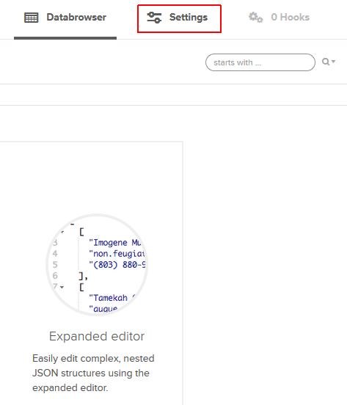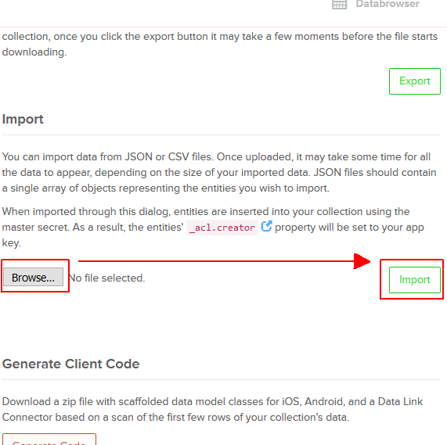
Kinvey will automatically create REST services to access your data.

Test the Kinvey REST Services
Using Postman or other HTTP client tool (you can use Kinvey’s built-in API Console), test the REST service endpoints:

User Registration (Sign Up)
POST https://baas.kinvey.com/user/app_id/
Request headers | Authorization: Basic base64(app_id:app_secret)  Content-Type: application/json
Request body | {  "username": "new_user",  "password": "pass123",  "name": "New User"  }
Response  201 Created | {  "_id": "583f53bde004a9a90983f1b7",  "username": "new_user",  "password": "pass123",  "name": "New User",  …  }
Error response  409 Conflict | { "error": "UserAlreadyExists", "description": "This username is already taken. Please retry your request with a different username", "debug": "" }
Error response  401 Unauthorized | { "error": "InvalidCredentials", "description": "Invalid credentials. Please retry your request with correct credentials", "debug": "" }
The request needs “Basic” authentication. Use the Kinvey app_id and Kinvey app_secret as credentials.
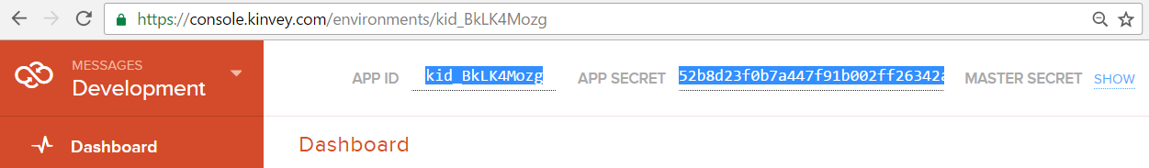

User Login
POST https://baas.kinvey.com/user/app_id/login
Request headers | Authorization: Basic base64(app_id:app_secret)  Content-Type: application/json
Request body | {  "username": "new_user",  "password": "pass123"  }
Response  200 OK | {  "_id": "583f53bde004a9a90983f1b7",  "username": "new_user",  "name": "New User",  "_kmd": {  "authtoken": "8e6471bc-3712-4cfb-b92e-50e62a0c80….Duj5fHdM /7XHIe6KdY="  …  },  …  }
Error response  401 Unauthorized | { "error": "InvalidCredentials", "description": "Invalid credentials. Please retry your request with correct credentials", "debug": "" }
Successful login returns an “authtoken” which is later used to authenticate the CRUD operations.

User Logout
POST https://baas.kinvey.com/user/app_id/_logout
Request headers | Authorization: Kinvey authtoken
Response
204 No Content
Error response  401 Unauthorized | { "error": "InvalidCredentials", "description": "Invalid credentials. Please retry your request with correct credentials", "debug": "" }
To logout, you need to provide the “authtoken” given by login / register as “Kinvey” authorization header.

List Messages by Recipient (My Messages)
Note: Keep in mind that the quotes used in the query must be exactly double quotes(").
GET https://baas.kinvey.com/appdata/app_id/messages?query={"recipient_username":"username"}
Request headers | Authorization: Kinvey authtoken
Response  200 OK | [  { "_id": "583eb40a8c70b21b6ffdb1d7",  "sender_username": "nakov",  "sender_name": "Svetlin Nakov",  "recipient_username": "maria",  "text": "Hi, Maria", ...  "_kmd": { "lmt": "2016-11-30T11:12:10.603Z", ... }  },  { "_id": "583eb430e004a9a909778b27",  "sender_username": "peter",  "sender_name": "Peter Ivanov",  "recipient_username": "maria",  "text": "Hi, Maria, I am Peter", ...  "_kmd": { "lmt": "2016-11-30T11:13:29.506Z", ... }  }, ...  ]
Error response  401 Unauthorized | { "error": "InvalidCredentials", "description": "Invalid credentials. Please retry your request with correct credentials", "debug": "" }

List Messages by Sender (Sent Archive)
GET https://baas.kinvey.com/appdata/app_id/messages?query={"sender_username":"username"}
Request headers | Authorization: Kinvey authtoken
Response  200 OK | [  { "_id": "583eb40a8c70b21b6ffdb1d7",  "sender_username": "nakov",  "sender_name": "Svetlin Nakov",  "recipient_username": "maria",  "text": "Hi, Maria",  "_kmd": { "lmt": "2016-11-30T22:49:49.889Z", ... }  },  { "_id": "583f45e2f161abf4170eccd8",  "sender_username": "nakov",  "sender_name": "Svetlin Nakov",  "recipient_username": "peter",  "text": "Msg from Nakov to Peter",  "_kmd": { "lmt": "2016-11-30T22:49:47.528Z", ... }  }, ...  ]
Error response  401 Unauthorized | { "error": "InvalidCredentials", "description": "Invalid credentials. Please retry your request with correct credentials", "debug": "" }

List All Users
GET https://baas.kinvey.com/user/app_id/
Request headers | Authorization: Kinvey authtoken
Response  200 OK | [  { "_id": "583d94a51e34b5f747…", "username": "peter", "name": "Peter Ivanov", … },  { "_id": "583d94c14ceec3…", "username": "maria", "name": "Maria Georgieva", … },  { "_id": "583f0e6f5d9865a425bb9394", "username": "guest", ... }, ...  ]
Error response  401 Unauthorized | { "error": "InvalidCredentials", "description": "Invalid credentials. Please retry your request with correct credentials", "debug": "" }

Send Message
POST https://baas.kinvey.com/appdata/app_id/messages
Request headers | Authorization: Kinvey authtoken  Content-Type: application/json
Request body | {  "sender_username":"peter",  "sender_name":"Peter Ivanov",  "recipient_username":"maria",  "text":"Hi, Maria. I am Peter"  }
Response  201 Created | {  "sender_username": "peter",  "sender_name": "Peter Ivanov",  "recipient_username": "maria",  "text": "Hi, Maria. I am Peter",  "_kmd": { "lmt": "2016-11-30T23:06:11.405Z", … },  "_id": "583f5b635d9865a425be9549"  }
Error response  401 Unauthorized | { "error": "InvalidCredentials", "description": "Invalid credentials. Please retry your request with correct credentials", "debug": "" }
Note: we know that this service endpoint allows sending fake messages. Client apps can send a message on behalf of someone else or on behalf of non-existing user. Recipient also might be non-existing. Don’t care about this: build your app to send messages using the currently logged-in sender and existing recipients.
All messages created by the above service get automatically assigned by Kinvey date (in ISO8601 format) in the field “_kmd.lmt” (last modify date).

Delete Message
DELETE https://baas.kinvey.com/appdata/app_id/messages/msg_id
Request headers | Authorization: Kinvey authtoken
Response  200 OK | {  "count": 1  }
Error response  404 Not Found | { "error": "EntityNotFound", "description": "This entity not found in the collection", "debug": "" }
Error response  401 Unauthorized | { "error": "InvalidCredentials", "description": "Invalid credentials. Please retry your request with correct credentials", "debug": "" }
Note that the currently logged-in user is allowed to delete only messages created by himself.

Messages – HTML and CSS
You аre given the Web design of the Messages application as HTML + CSS files.
- Initially all views and forms are shown by the HTML. Your application may hide by CSS (display: none) or delete from the DOM all unneeded elements or just display the views it needs to display.
- You may render the views / forms / components with React, jQuery, Mustache or another UI library.
Important: don’t change the elements’ class name and id. Don’t rename form fields / link names / ids.

Messages Client-Side Web Application
Design and implement a client-side front-end app (SPA) for managing the messages. Implement the functionality described below.

Navigation System
Implement a navigation system for the app: navigation links should correctly change the current screen (view).
- Clicking on the links in the top navigation bar should display the view behind the link (views are sections in the HTML code).
- Your application may hide by CSS (display: none) or delete from the DOM all unneeded elements or just display the views it needs to display.
5 score

Home Screen
When no user is logged in, the app should display the "Home" screen holding a welcome message + three links: [Home], [Login] and [Register].
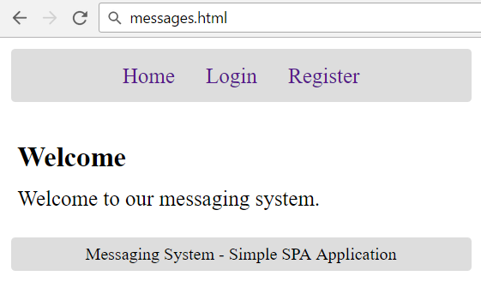
5 score

Register User Screen
By given username + password + name the app should register a new user in the system.
- After a successful registration, a notification message “User registration successful.” should be displayed and the user home screen should be displayed.
- In case of error, an appropriate error message should be displayed and the user should be able to try to register again.
- Form validation is already implemented in the HTML, so you don’t need to add it.
- Keep the user session data in the browser’s session storage.
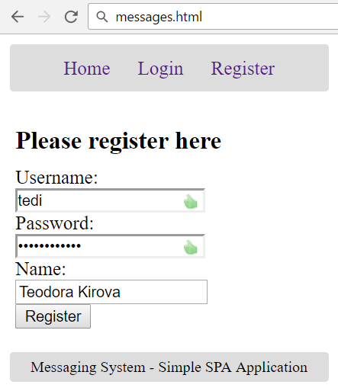
10 score

Login User Screen
By given username and password the app should be able to login an existing user.
- After a successful login, a notification message “Login successful.” should be displayed and the user home screen should be displayed.
- In case of error, an appropriate error message should be displayed and the user should be able to fill the login form again.
- Form validation is already implemented in the HTML, so you don’t need to add it.
- Keep the user session data in the browser’s session storage.
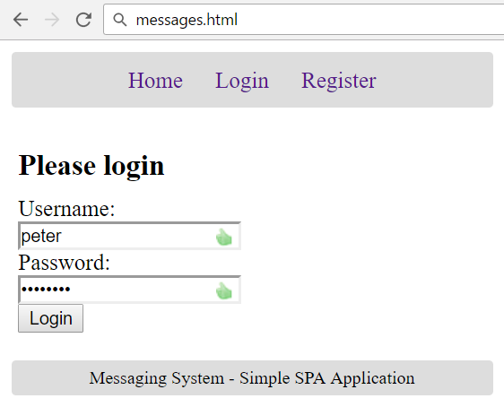
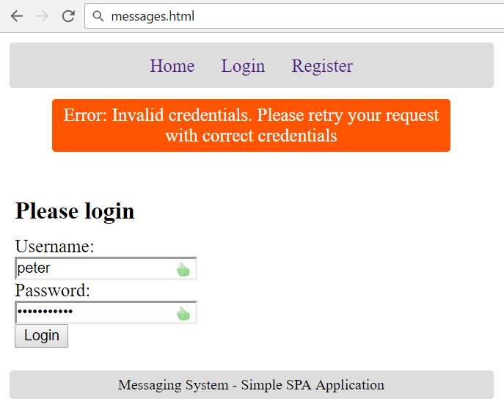
5 score

Logout
Successfully logged in user should be able to logout from the app.
- After a successful logout, a notification message “Logout successful.” should be displayed.
- After successful logout, the Home screen should be shown.
- The “logout” REST service at the back-end should be obligatory called at logout.
- All local information in the browser (user session data) about the current user should be deleted.
5 score

User Home Screen
After successful login, the app should display the user's home screen.
- It should hold a message “Welcome, ” + the username of the current user.
- At the top navigation bar display the navigation links [Home], [My Messages], [Archive (Sent)], [Send Message] and [Logout] + “Welcome, {username}”.
- At the main view area display navigation boxes [My Messages], [Archive (Sent)] and [Send Message].
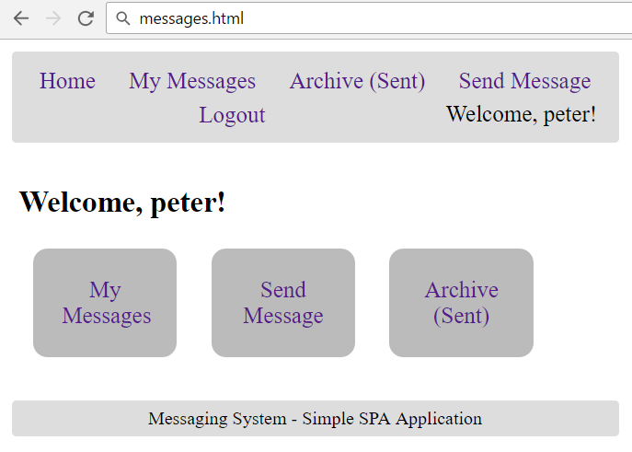
- Ensure you handle properly all HTML special characters, e.g. the username could be "<peter><br>".
5 score

Received Messages Screen
Successfully logged users after clicking the [My Messages] link should be able to view all messages, sent to current user, i.e. recipient_username == {current_username}.
- The messages should be listed in the format as shown in the Web design (see the screenshot below).
- In case of error (e.g. Internet connection lost), an error message should be displayed.
- In case of no messages, display an empty table (header row only).
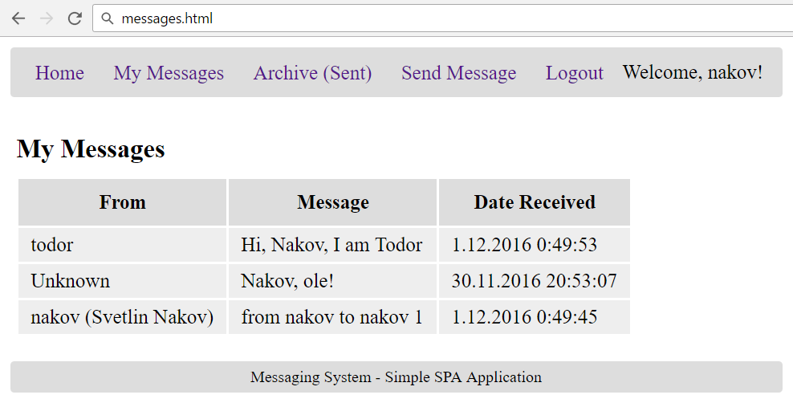
- Format the message sender and date as shown in the screenshot above. You may use the following helper functions to format dates and senders:
function formatDate(dateISO8601) {
let date = new Date(dateISO8601);
if (Number.isNaN(date.getDate()))
return '';
return date.getDate() + '.' + padZeros(date.getMonth() + 1) +
"." + date.getFullYear() + ' ' + date.getHours() + ':' +
padZeros(date.getMinutes()) + ':' + padZeros(date.getSeconds());
function padZeros(num) {
return ('0' + num).slice(-2);
}
}
function formatSender(name, username) {
if (!name)
return username;
else
return username + ' (' + name + ')';
}
- Ensure you handle properly all HTML special characters, e.g. the message text could hold "Hi, <peter>".
20 score

Sent Messages Screen
Successfully logged users after clicking the [Archive (Sent)] link should be able to view all messages, sent by the current user, i.e. sender_username == {current_username}.
- The messages should be listed as shown in the Web design (see the screenshot below).
- In case of error (e.g. Internet connection lost), an error message should be displayed.
- Display [Delete] button for each sent message. The button will delete the message.
- In case of no messages, display an empty table (header row only).
- Ensure you handle properly all HTML special characters, e.g. the message text could hold "Hi, <peter>".
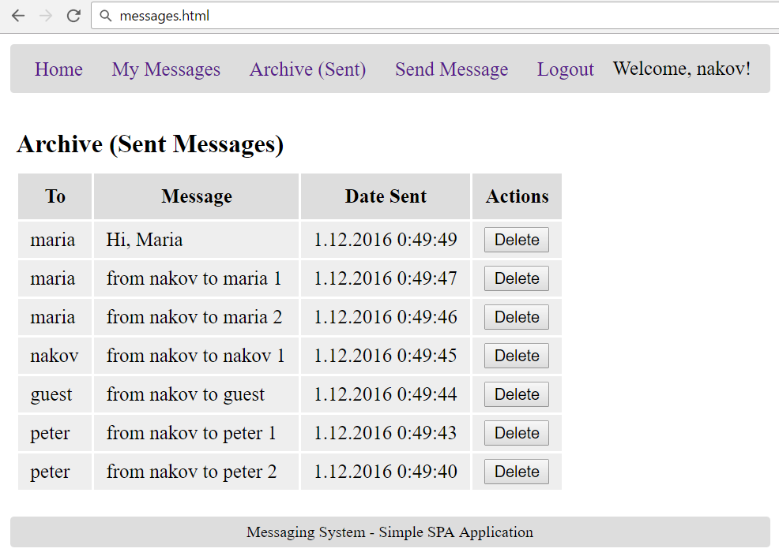
15 score

Delete Message Screen
Successfully logged in users should be able to delete their sent (archive) messages by clicking on the [Delete] button in the table above.
- After successful message delete a notification message “Message deleted.” should be shown.
- In case of error (e.g. Internet connection lost / unauthorized request / missing message), an error message should be displayed.
- Deleting works immediately, with no confirmation.
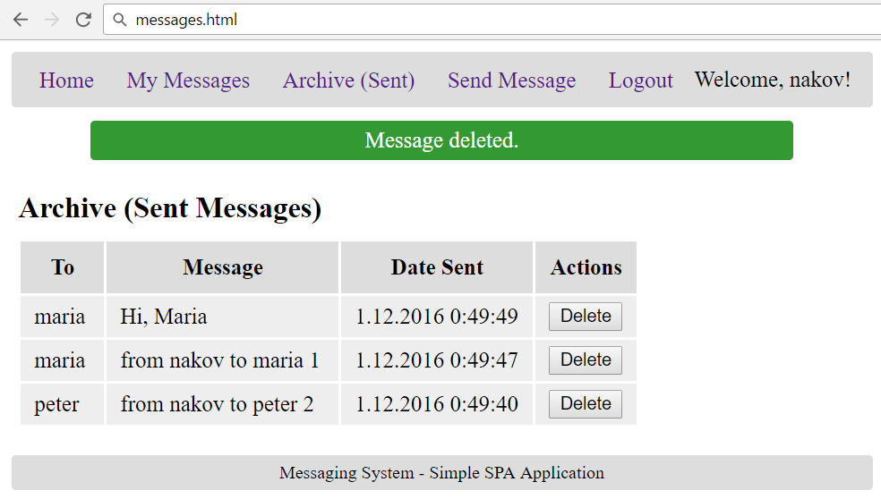
10 score

Send Message Screen
Successfully logged in users should be able to send new messages by choosing an existing recipient, entering a text and clicking the [Send] button.
- Before the “send message” form is shown, it should first load all users from the back-end and display them into the drop-down list of recipients.
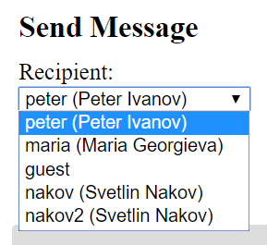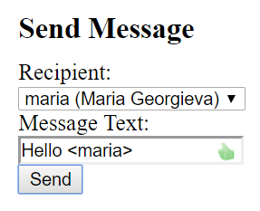
- After a successful message sending, a notification message “Message sent.” should be displayed and all sent messages (archive) should be shown.
- In case the sender has no name, null should be passed in its place.
- In case of error, an appropriate error message should be displayed and the user should be able to fill the “send messages” form and try again.
- Form validation is already implemented in the HTML, so you don’t need to add it.
- Ensure you handle properly all HTML special characters, e.g. the message text could hold "Hi, <peter>".
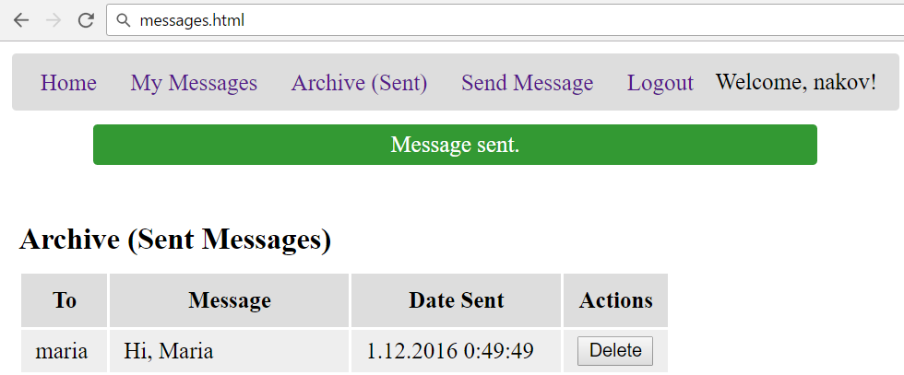
20 score

Notifications
The application should notify the users about the result of their actions.
- In case of successful action an informational (green) notification message should be shown, which disappears automatically after 3 seconds or manually when the user clicks it.
- In case of error, an error notification message (red) should be shown which disappears on user click.
- During the AJAX calls a loading notification message (blue) should be shown. It should disappear automatically as soon as the AJAX call is completed.
Good luck!

